|  |
| --- |
| **New standards: Task Server Installation** |

1 Intro 2

2 Prerequisites 2

3 Workflow installation 3

4 Verify the installation 4

# Intro

This manual is focused on the deployment of a task server on the new standards of JDN with an automated workflow installation.

This manual should only be used on servers that have been deployed from a task server template.

# Prerequisites

An active task server that is deployed from template on the correct fixed IP address: X.X.X.15

An active VPN connection

**If the site will not have a VPN connection when it is installed on site a configuration change will need to be performed by the ICT System Engineers after it has been deployed.**

Member of the JDN_GAP_ALTIRIS_SITE_SERVER_DEPLOYMENT_CONSOLE AD group for access to the workflow

# Workflow installation

Go to <http://vm-alt-wf01.jandenul.com/SiteServerDeployment/> you will be presented with the following form:

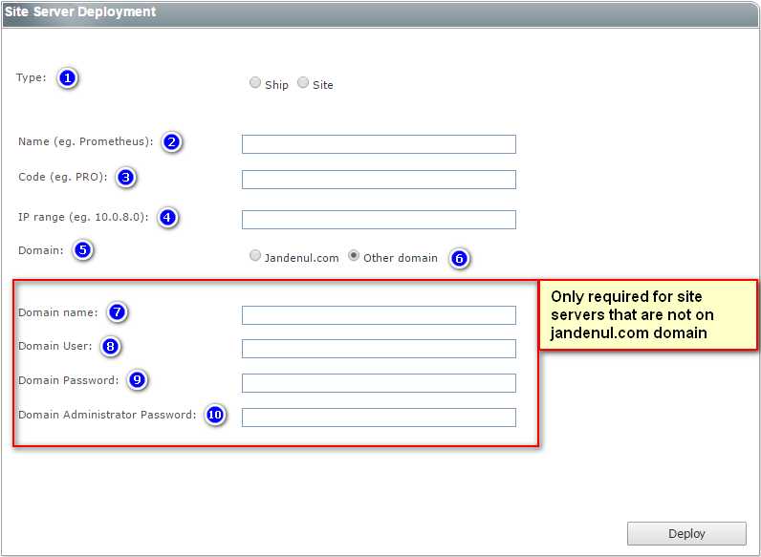

1. Select the appropriate type
2. Enter the full name of the site/ship
3. Enter the short name of the site/ship
4. Enter the **IP range** of the site/ship  
   **Note: This is not the IP address of the task server!!!**
5. If you select jandenul.com here the you can click deploy to move on to the next steps
6. If you select other domain another part of the form will become visible
7. Enter the name of the domain (for example IN.SITUS)
8. This field will be filled in automatically in the following format [srv_altirisns@IN.SITUS](mailto:srv_altirisns@IN.SITUS)
9. Enter the password of the srv_altirisns user
10. Enter the password of the domain administrator account and click Deploy

After entering this data you will configure each part of the process by a wizard like deployment (next, next). **Should any of these steps fail for some reason is it very important to not execute the same steps twice as this could cause data corruption in the Altiris environment!**

# Verify the installation

After completing the workflow there should be an agent installed on the management, apps and tasks VM. You can verify this by going to the VM and clicking the Symantec Management Agent icon as shown below.



After 2-4 hours all the functionality should be available in the task server agent and it should have a package server tab in the agent. From this moment on it will start syncing the packages to the server. You can check this progress by watching the ready packages in the package server tab.

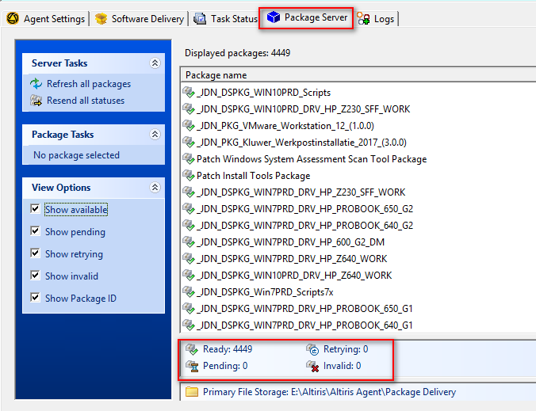

By default the package server will only use 10% of the available bandwidth. If you want to speed up the syncing of the packages you can **temporary** uncheck the following checkbox.

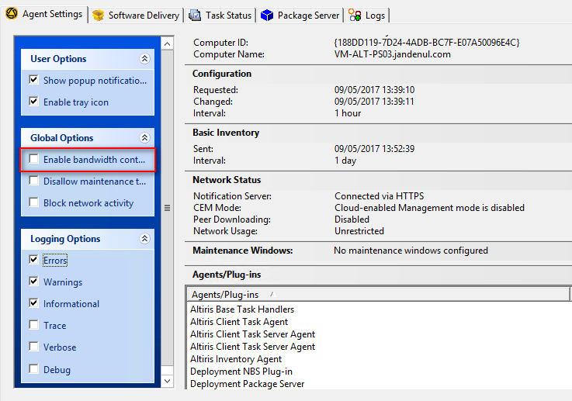

**It is important that this option is enabled again after all packages have been synced.**

# ESET Configuration

When the tasks server has been installed, you have to configure ESET in order to make the VM's sync the correct antivirus databases.

Open the ESET Remote Administrator Console

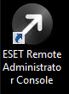

Go to 'Tools' 🡪 'Server Options…'

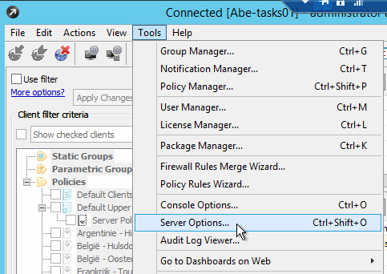

In the tab 'Updates', make sure the update server is correct:

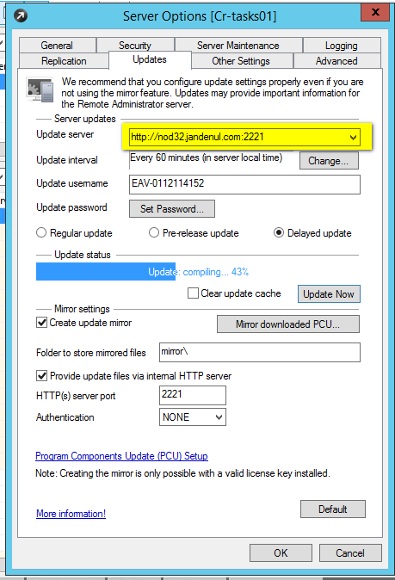

Click on 'Update Now', if a message pops up to apply the configuration first, click 'Yes'. The progress bar should get a 'Finished' status:

